**Employee Management**

The Employee Management System is a command-line interface (CLI) application designed to streamline the process of managing employee records. The system allows employees to:

* **Register**: Create a new account by entering their personal and contact details.
* **Login**: Securely access their account using a registered email and password.
* **Update Details**: Modify or update personal information as needed.
* **Delete Account**: Remove their account from the system permanently.

This project simplifies employee data handling and provides a secure and efficient way to manage employee information in a text-based environment.

**Database Schema**

create table if not exists employees (

id serial primary key,

first_name text not null,

last_name text not null,

joining_date date not null,

location text not null,

salary int not null, -- (monthly salary)

currency text not null,

password text not null

);

**Screenshots**

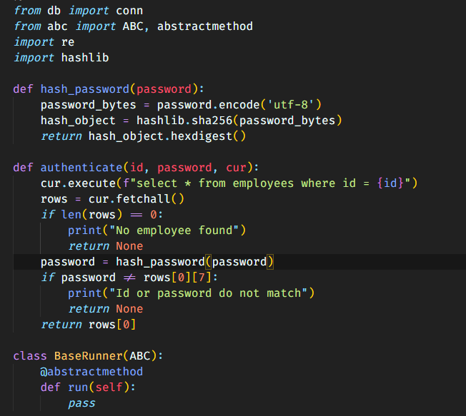

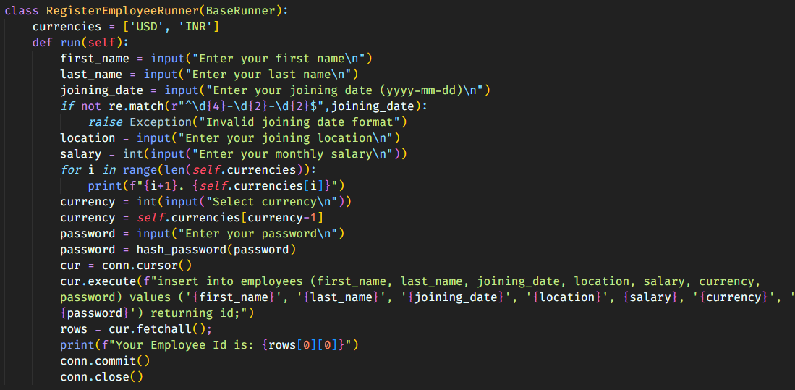

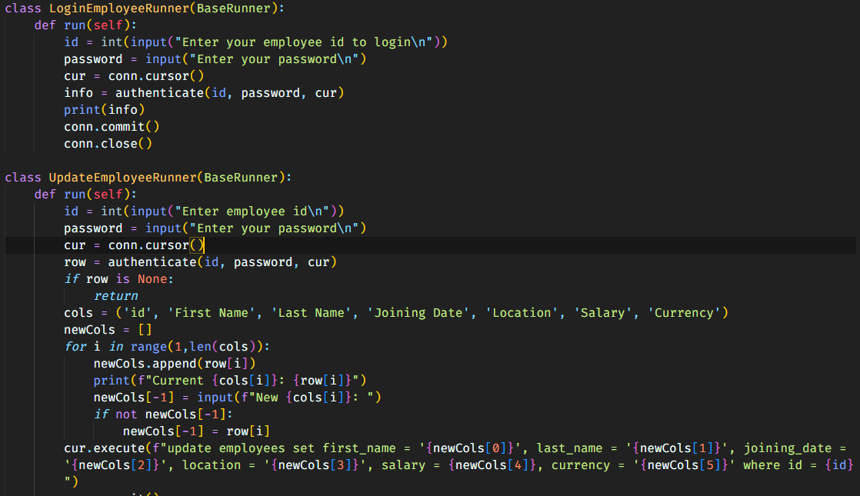

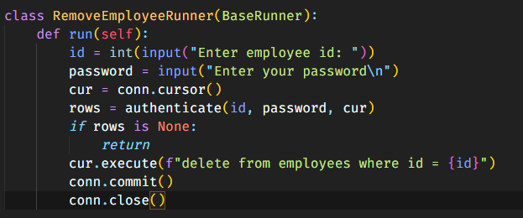

**Output ScreenShots**

